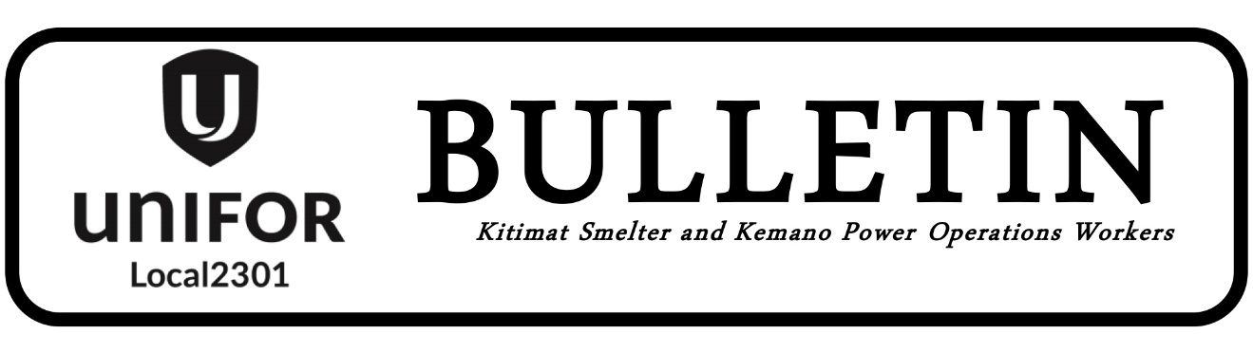

SHOP STEWARDS COUNCIL MEETING

This is a Notice of Motion to post regarding proposed Bylaw changes to Section 6, 7, 8 & 9 of the Shop Steward Council Bylaws. The proposed Bylaw changes will be voted on at the next Shop Stewards Council meeting being held on

Tuesday, June 14, 2022 @ 7:00 pm at the Union Hall

All Shop Stewards are encouraged to attend.

